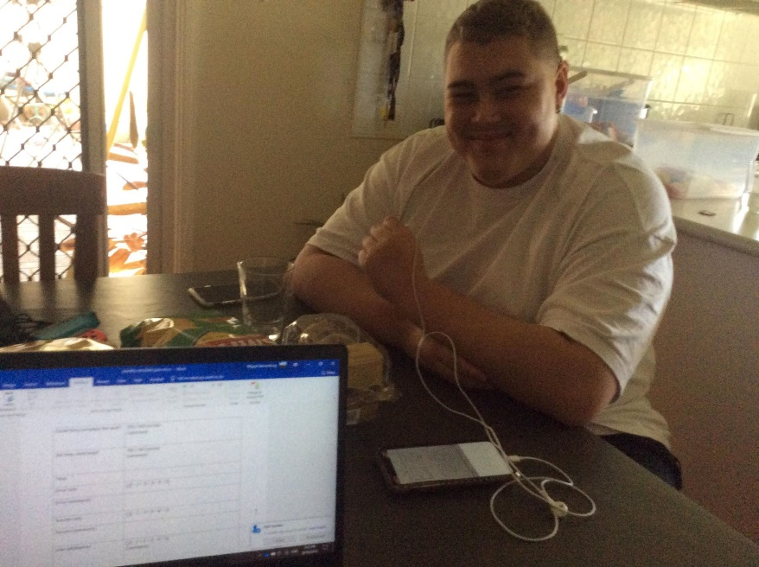*USABILITY TESTING*

Name of the participant: Jack Carter

*M.E.H*

Time of the activity: 3:40 Date of the activity: 8/10/19

**Facilitatory help notes:** Give them the task, but do not tell them how to complete it. Ask them to talk out loud while they do it. Did they complete the task? Did they need help? Explain where they needed help? How long did it take for them to complete that task?, What was the error rate (0 – no errors, 5 a lot of errors), this allows us to communicate through quantitative data. Explain why and where those errors occurred. Similar process to success rate (0 – no success – 5 great success) – success can be measured on errors, but more so on confusion and how easy it was. User satisfaction (0 poor – 5 great) comment on when, where, why and how. General comments about the task, more so about body language, and think aloud comments. After testing is complete gather themes and insights, and personal solutions you or the individual believes would be appropriate.

# Application: Yes

Task: Using the visual representation, set up an account.

Kyle, Emily, Mon.

|  |  |
| --- | --- |
| Could they complete the task? | YES / NO (circle) Comment: |
| Did they need help? | YES / NO (circle) Comment: |
| Time | 13 seconds |
| Error rate | ( 0 – 1 – 2 – 3 – 4 – 5) |
| Error comments | No errors |
| Success rate | ( 0 – 1 – 2 – 3 – 4 – 5) |
| Success comments | Task was completed |
| User satisfaction | ( 0 – 1 – 2 – 3 – 4 – 5)  Comments: “Simple to do, everything came as expected” |
| General comments | “Once again, was it simple, told you what details, You can see Gmail account, service NSW, or thru email”  “Add in social media since everyone is using it because social media is such a big part of life now” |
| Common themes and insights | Being provided with a choice is what empowers the user to believe it’s familiar and trustworthy. |
| Suggested solutions | N/A |

Task: So you have the application – set up the Bluetooth from the visual representation. (Connect to the wearable)

|  |  |
| --- | --- |
| Could they complete the task? | YES / NO (circle) Comment: |
| Did they need help? | YES / NO (circle) Comment: |
| Time | 25 seconds |
| Error rate | ( 0 – 1 – 2 – 3 – 4 – 5) |
| Error comments | “Sorry, which one?” |
| Success rate | ( 0 – 1 – 2 – 3 – 4 – 5) |
| Success comments | You need to scan – (pressed scan too many times, but saw it) |
| User satisfaction | ( 0 – 1 – 2 – 3 – 4 – 5)  Comments: “That’s pretty straight forward and was good” |
| General comments | Straight forward and simple, easy to get to – I’m sure everyone could get used to it it’s right in front of you |
| Common themes and insights | Being able to make it similar |
| Suggested solutions | N/A – pretty good how its designed – everyone will get used to that |

Task: Using the visual representation – transfer money to the wearable.

|  |  |
| --- | --- |
| Could they complete the task? | YES / NO (circle) Comment: |
| Did they need help? | YES / NO (circle) Comment: |
| Time | 15:95 |
| Error rate | ( 0 – 1 – 2 – 3 – 4 – 5) |
| Error comments | N/A |
| Success rate | ( 0 – 1 – 2 – 3 – 4 – 5) |
| Success comments | “easy to send money” |
| User satisfaction | ( 0 – 1 – 2 – 3 – 4 – 5)  Comments: Suggested amount? Surprising, personally wouldn’t give $200 – good options – (need an option to change it) |
| General comments | Straight forward to send money – simple, maybe a little bit structure or clarity – let me know what its doing  Pretty much the same as afterpay – taken out |
| Common themes and insights | Being provided an opportunity to change the amount you’re giving |
| Suggested solutions | N/A |

Task: From the visual representation, find what was the most recent activity on the Com-it wearable.

|  |  |
| --- | --- |
| Could they complete the task? | YES / NO (circle) Comment: |
| Did they need help? | YES / NO (circle) Comment: |
| Time | 11:40 |
| Error rate | ( 0 – 1 – 2 – 3 – 4 – 5) |
| Error comments | N/A |
| Success rate | ( 0 – 1 – 2 – 3 – 4 – 5) |
| Success comments | “You can see everything they’ve done with your money that’s good” |
| User satisfaction | ( 0 – 1 – 2 – 3 – 4 – 5)  Comments: |
| General comments | Showed everything with exact time and the money spent – and whats the remaining -   Presenting well where everything is, how much they spent and the money you’ve given them |
| Common themes and insights | Being able to see use in context is very important |
| Suggested solutions | N/A |

Task: Using the visual representation, try and send a text to the com- it wearable using the application.

|  |  |
| --- | --- |
| Could they complete the task? | YES / NO (circle) Comment: |
| Did they need help? | YES / NO (circle) Comment: |
| Time | 8:65 |
| Error rate | ( 0 – 1 – 2 – 3 – 4 – 5) |
| Error comments | N/A |
| Success rate | ( 0 – 1 – 2 – 3 – 4 – 5) |
| Success comments | “Straight forward pretty simple” |
| User satisfaction | ( 0 – 1 – 2 – 3 – 4 – 5)  Comments: “It’s like a normal text message I think” |
| General comments | “So if it's something like very important, maybe you have to send short, sharp messages at a time. So it's like multiple messages for them to get like to understand that it gets through to them. But other than that, it's pretty straightforward.” |
| Common themes and insights | By mimicking real life, the users can find some familiarity by using the app |
| Suggested solutions | Multiple messages, or predetermined template messages |

Task: Imagine you want to problematic gambler to reduce their limit over time, the application allows for that – try and reduce the com-it level (hint – it’s in settings)

|  |  |
| --- | --- |
| Could they complete the task? | YES / NO (circle) Comment: |
| Did they need help? | YES / NO (circle) Comment: didn't realize that little “apps” (icon) on the top there was the, like, the limit settings pop up. |
| Time | 18 sec |
| Error rate | ( 0 – 1 – 2 – 3 – 4 – 5) |
| Error comments | User didn’t get the top button |
| Success rate | ( 0 – 1 – 2 – 3 – 4 – 5) |
| Success comments | Straight forward - |
| User satisfaction | ( 0 – 1 – 2 – 3 – 4 – 5)  Comments: |
| General comments | Didn’t realise that was the logo button, I might touch that to see what it does = the top right icon  Pretty good, the settings screen, I like the design of this |
| Common themes and insights | Recognition rather than recall should be altered |
| Suggested solutions | Make the iconography stand out a bit more in future |

Task: From the visual representation – how long is it until you are allowed to send money again?

|  |  |
| --- | --- |
| Could they complete the task? | YES / NO (circle) Comment: |
| Did they need help? | YES / NO (circle) Comment: |
| Time | 1:00 |
| Error rate | ( 0 – 1 – 2 – 3 – 4 – 5) |
| Error comments | Wait what wait what I’m trippin |
| Success rate | ( 0 – 1 – 2 – 3 – 4 – 5) |
| Success comments | Had to reset the app - |
| User satisfaction | ( 0 – 1 – 2 – 3 – 4 – 5)  Comments: |
| General comments | 24 hours – well that’s good then, you can change the amount and give them minimal amounts  Wasn’t proper but when its there right at the start, I’d like to lookb ack on the timer, and see how much thye’ve spent over the 24 hours they’ve been given  Every hour get notifications on how longs left – amount of money left on the wearable |
| Common themes and insights |  |
| Suggested solutions |  |

# WEARABLE: YES

Task: Using the visual representation connect the device to the application,

|  |  |
| --- | --- |
| Could they complete the task? | YES / NO (circle) Comment: |
| Did they need help? | YES / NO (circle) Comment: |
| Time | 19:00 |
| Error rate | ( 0 – 1 – 2 – 3 – 4 – 5) |
| Error comments | N/A |
| Success rate | ( 0 – 1 – 2 – 3 – 4 – 5) |
| Success comments | Pretty straight forward – was only stuck based on drawings and not knowing they were apps |
| User satisfaction | ( 0 – 1 – 2 – 3 – 4 – 5)  Comments: |
| General comments | Was simple, right there, find the person you need to reach quite easily |
| Common themes and insights | Quite easy to use, not extremely hard, may take a couple of times to use |
| Suggested solutions | Easy , connecting would be easy |

Task: from the visual representation – how much money did the application send you - how much do you have to spend to gamble? (Hint Notif bar)

|  |  |
| --- | --- |
| Could they complete the task? | YES / NO (circle) Comment: |
| Did they need help? | YES / NO (circle) Comment: |
| Time | 40:00 |
| Error rate | ( 0 – 1 – 2 – 3 – 4 – 5) |
| Error comments | Hold on a sec – got lost – saw messages first |
| Success rate | ( 0 – 1 – 2 – 3 – 4 – 5) |
| Success comments | DON’T THINK ILL GET ANYMORE MONEY |
| User satisfaction | ( 0 – 1 – 2 – 3 – 4 – 5)  Comments: |
| General comments | Had to niggle around – but its presented in the options Good to know that you can only take $10 at a time, not the whole amount at once - |
| Common themes and insights | 400 in 3 hours – a quite good stat to present first |
| Suggested solutions | I think that options of having out $10, 20 or 50 |

Task: Get cash out Hint (10).

|  |  |
| --- | --- |
| Could they complete the task? | YES / NO (circle) Comment: |
| Did they need help? | YES / NO (circle) Comment: |
| Time | 19:00 |
| Error rate | ( 0 – 1 – 2 – 3 – 4 – 5) - fail |
| Error comments | Cannot find, because the top, notification wasn’t known |
| Success rate | ( 0 – 1 – 2 – 3 – 4 – 5) - Fail |
| Success comments |  |
| User satisfaction | ( 0 – 1 – 2 – 3 – 4 – 5) – hally when it actually did work  Comments: |
| General comments | Good to have option to choose to get the money or not – good to have it in front of you face – not knowing how much money |
| Common themes and insights |  |
| Suggested solutions | Confused about taking $10 at time |

Task: What the bar – from the visual representation how much money do you have left to spend?.

|  |  |
| --- | --- |
| Could they complete the task? | YES / NO (circle) Comment: |
| Did they need help? | YES / NO (circle) Comment: |
| Time | 5:00 |
| Error rate | ( 0 – 1 – 2 – 3 – 4 – 5) – no error |
| Error comments | NOne |
| Success rate | ( 0 – 1 – 2 – 3 – 4 – 5) – complete success |
| Success comments | Really easy to use, wow I don’t want to be in debt to the person who gave me money |
| User satisfaction | ( 0 – 1 – 2 – 3 – 4 – 5)  Comments: |
| General comments | Personally, after having that much money of a loss I wouldn’t want to keep chasing, IO’ve already lost, I don’t want to be 500 dollars down  Receiving a message – time to come home midway thru – that’s enough time, you spent enough time – you would be really angry, and you can’t chase losses as the hopes been taken away |
| Common themes and insights |  |
| Suggested solutions | If I’ve taken a lot of losses, worse in that environment, follow the testamonials option of what they’ve messaged,  Notifications of reminder – the ‘pop up’ have the pop up of the time you’ve been there |

Task: Use the com-it to spend more money.

|  |  |
| --- | --- |
| Could they complete the task? | YES / NO (circle) Comment: |
| Did they need help? | YES / NO (circle) Comment: |
| Time | 30:08 |
| Error rate | ( 0 – 1 – 2 – 3 – 4 – 5) |
| Error comments | none |
| Success rate | ( 0 – 1 – 2 – 3 – 4 – 5) |
| Success comments | Option of take cash out – seeing 2% win rate – success, take cash out – goodo to know what you have as remainder |
| User satisfaction | ( 0 – 1 – 2 – 3 – 4 – 5)  Comments: |
| General comments | Gives youa clear idea about how you’re winning/or losing to find out that you’r eonly winning 2% and you’re actually losing |
| Common themes and insights |  |
| Suggested solutions |  |

Task: The com-it has ran out of money – what next? How long until you can get more money?

|  |  |
| --- | --- |
| Could they complete the task? | YES / NO (circle) Comment: |
| Did they need help? | YES / NO (circle) Comment: |
| Time | 1:22 |
| Error rate | ( 0 – 1 – 2 – 3 – 4 – 5) |
| Error comments | Went straight to the 0 – take out cash, does this means that it’s $10, didn’t understand that there’s |
| Success rate | ( 0 – 1 – 2 – 3 – 4 – 5) |
| Success comments | Didn’t really work |
| User satisfaction | ( 0 – 1 – 2 – 3 – 4 – 5)  Comments: if there’s various people on there, certain amount of money being transferred, at the ned of the day it might be bad. You don’t want debt towards majority of this people |
| General comments SPECIFICALLY ON THIS ONE – HOW DO THEY FEEL | It’s a pretty good to undersand that you’re back to 0 – but I didn’t understand that I was back to 0;  You’d probably want more money from them, if there’s only that one person that I can trust then obviously I’d have to stop. Taking the money away is key, personw ho’s gambling but it saves them,   Need to add in something with money gone -s tat that the $10 being given, and show that you won nothing from $10  Maybe that’s enough gambling – implement timers – offer or prompt to give water – maybe stree to have a ciggarete, or suggest talking to someone else- direct a phone call that’s given   Quite good examples – wth events get your mind off gambling and in social areas, get away form the environment would be good for you |
| Common themes and insights |  |
| Suggested solutions | Can’t blackmail with the lock in, that’s a good option I think   I don’t know, it’s a good option |

Post testing survey based of criteria and concept viability.

|  |  |  |
| --- | --- | --- |
| CRITERIA | YES/NO | WHY and WHAT DO YOU THINK ABOUT THAT? |
| Does the product deter problematic behaviour? | Yes | This app does show a person who uses it that they do often spend money gambling on that activity page |
| Does the product reduce stress? | NO | For me, seeing money that often and the stats that I’m losing would make me really anxious and want to do something about it |
| Does this product empower you to re-evaluate their choices? | Yes | Being shown a lot, like people showing |
| Does the product allow for a personalised experience? | NO | Wouldn’t all people have the same version of the app and the way I saw it, the only thing that would change is the person whos messaging you |
| Does the product educate you on problematic behaviour? | Yes | The stats of you losing do that |
| Does this product inform you on your lack of control? | Yes | Showing you the money loss does that |
| Is this product easy to use | Yes | It was simple enough, I needed help the first way round because I couldn’t read it but I could’ve gotten used to it |
| Does this product allow gamblers to identify when they have a problem? | Yes | This allows people to tell you that you have a problem but also show you mass amounts of spending which is really good |
| Would you use this product to minimise gambling related harm? | Yes | I would, I currently don’t gamble that much but I think it’d help show me how much I’m losing and how many better things I could do with it |
| Do you believe this product is viable? Would you ever contemplate use it? | Yes | I think it really works, because obviously pokies places wouldn’t really wanna help you stop and I couldn’t think of any ways to do it otherwise |

Facilitatory help notes: All questions aim to spark conversation, go on a tangent. See what can be done better. However, ensure the questionnaires are answered with yes/no, so quantitative data can be collected alongside the qualitative data. Always ask why.